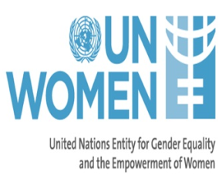
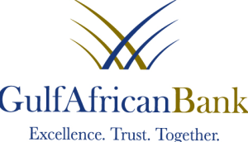

Gulf African Bank opens procurement opportunities to Women Owned Businesses (WOBs) in Nakuru
Gulf African Bank has embarked on an exciting and innovative journey in partnership with UNWomen to open up business opportunities for WOBs in the GAB supply chain. We seek to be a leader in promoting supplier diversity and inclusion under the Annisaa program, through Women’s Entrepreneurship and Networking Workshops (WENF).
Nakuru, 15th - 16th November 2017- Gulf African Bank, Kenya’s premier SME Shari’ah compliant bank, is holding the 3rd conference this year. The conference is so as to promote supplier diversity and inclusion, an initiative that is aimed at raising awareness on procurement opportunities and access to trade finance, as well as enhancing the procurement readiness for WOBs in Nakuru and the rest of the country.
The two-day event, organized in partnership with UN Women and opened by Mrs. Susan Kihika, Senator of Nakuru County, brought together WOBs seeking to gain practical skills in submitting responsive bids and network amongst themselves. The training is aimed at ensuring that WOBs also benefit from Gulf African Bank’s unsecured trade finance products. Some of the products that GAB offer include unsecured LPO financing of up to 20 million for those with prior performance history and upto 3 million unsecured LPO business for starters
Nakuru Senator, Susan Kihika, commended GAB and UN Women for bringing the empowerment program to the country’s devolved units. “Boosting the participation of women in economic development, as well as making opportunities available to them especially at county level is crucial to their socio-economic growth and the larger society’s at large” she said.
Speaking during the conference, GAB MD Abdalla Abdulkhalik said “The achievement of women economic empowerment is a journey. A journey that looks at the availability of economic resources and skills, opportunities and benefits as well as enabling the beneficiaries to have control over available resources. At GAB, we are proud to announce that through our intensive women banking program, we take care of all this through our pillars; educate, empower and protect. Partnering with women in business at county level is a key focus area for the bank”.
During the forum, UN Women Deputy director Karen Fueg observed that empowerment of women serves to break the chains of dependency that affect women across the nation. Costs of excluding women in county and national development manifest themselves in slow socio-economic growth, as their potential is not exploited to the maximum.
The 2-day program included a panel discussion on sourcing from women. The session's panelists comprised of experts from various sectors such as entrepreneurship, Trade Finance, Taxation and Procurement. They included UN Women’s Banu Khan, Ernst & Young LLP’s Lydia Ndirangu, and Ms. Wanjiru Gathira - Immediate Chairperson Uwezo amongst others.

Gulf African Bank
Fathia.abdulle@gab.co.ke (+254 20 2740000)

Paul Karingithi
paul.karingithi@catapult.co.ke (+254 721 678828)

About Gulf African Bank
Gulf African Bank is the Premier Shari’ah compliant SME bank in Kenya, offering products that address the needs of not just Muslims, but everyone in the country through fair, safe and ethical banking practices. Gulf African Bank is a pioneering Islamic Bank not only in Kenya but also in the entire East African region, whose shareholders include: Dubai World (the investment arm of the Government of Dubai); BMI Bank (a leading regional bank headquartered in Bahrain); Sheikh Abdullah Mohammed Al Romaizan (a leading investor from Saudi Arabia); PTA Bank, GulfCap (UAE), IFC (World Banks Private Investment Arm) and prominent Kenyan nationals.
www.gulfafricanbank.com
About Annisaa
GAB has a women specific program called ‘Annisaa’ which is embedded in three pillars – Empower, Educate and Protect that which matters to women most. Annisaa offers unique and innovative financial products designed specifically for women.
http://www.gulfannisaa.co.ke/index.php/about-us
About UN Women
UN Women is a UN organization dedicated to gender equality and the empowerment of women. A global champion for women and girls, UN Women was established to accelerate progress on meeting their needs worldwide.
africa.unwomen.org
Ends

